Luke Evans

March 10th, 2021

Lab 7 – VPN

*Task 1: VM Setup*

Host U is on the NAT network as 10.0.2.15:

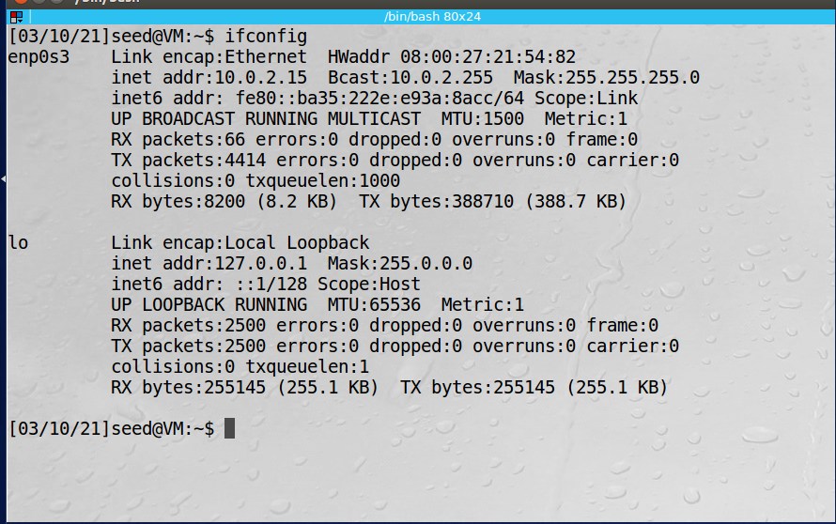

VPN server/gateway is on NAT network as 10.0.2.4 and on internal network as 192.168.60.1:

Host V is on the internal network only as 192.168.60.101:

From the server I can ping Host V:

However, from Host U I cannot currently ping Host V:

Observations: In this task we setup the network that will be used to create a VPN tunnel. There are three VMs on our network: Host U (10.0.2.15), VPN server/gateway (10.0.2.4/192.168.60.1) and Host V (192.168.60.101). Currently Host U is unable to communicate with Host V because Host V is only reachable through the internal network. This was shown in the screenshots above when we tried to ping Host V from Host U.

Explanation: The VPN server/gateway machine has two network interfaces configured so that it can communicate with external VMs as well as the internal network. Once we configure our VPN tunnel from Host U to our VPN server then Host U should be able to connect to Host V. By placing the VMs on separate networks, we are able to simulate the VMs being connected over the internet.

*Task 2: Creating a VPN Tunnel using TUN/TAP:*

First we update the IP address of our VPN server in our VPN client program:

Step 1: Run VPN Server:

We run the VPN server on our server machine:

Then we configure tun0 on our vpn server:



Next we have to enable forwarding since our server will be acting as a gateway to our internal network:

Step 2: Run the VPN Client:

We run our vpn client program on Host U with IP 10.0.2.15:

Then we configure the tun0 interface that will be used by the client:



We can see the connection on our vpn server with the Hello message:



We can see on Host U, that we have received packets from tun0:

Step 3: Routing on the Client and Server VMs:

In the screen show below we display the routing table on Host U:

We need to add a route for all packets directed to the private network 192.168.60.0/24 network to use our tun0 interface. After setting the route, we again look at our routing table on Host U:

We also check our routing on our server to confirm the routes are set correctly:

Step 4: Setup routing on Host V:

Before we configure any additional routing on host v the routing table is displayed:

Next we need to add a route for our VPN network IP, 192.168.53.0/24:

Step 5: Test the VPN

We ping Host V from Host U to verify we are connected via the VPN tunnel:

We also can connect via telnet command:

Using wireshark we can see that when we ping 192.168.60.101, the source is our tun0 IP address of 192.168.53.5:

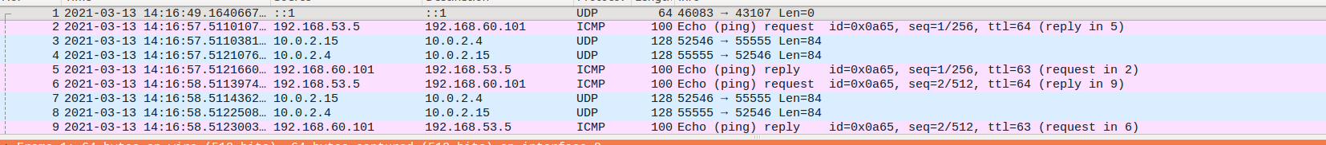

However, when we ping a different IP that is not routed through tun0 then we get our VM IP of 10.0.2.15:

Step 6: Tunnel-Breaking Test

While telnet is still active, we kill both our vpn server and client programs:

When we try to type commands into our telnet window appears to be frozen.

However, it seems the requests are buffered because when I reenable the vpn and configure the routing, all of the ls commands I typed execute and my telnet session is still active:

Explanation: In this task we setup a VPN tunnel between our VPN client on an external network and our VPN server. Once the tunnel was established our Host U was able to pass requests destined for the internal network through the VPN tunnel and talk to Host V that is only reachable internally. To do this we configured our VPN server program, set the tun0 interface, and allowed forwarded so that the server could act as a gateway. Then we ran our vpn client program on Host U and routed traffic destined for the internal network 192.168.60.0/24 to use the tun0 interface. Finally, we configured Host V to responde to VPN packets through the VPN server. Once all this was done we are able to ping and telnet from Host U to Host V. As a final experiment we broke the VPN connection which seemed to cause our telnet session to freeze. However, the packets were being buffered so when we reconnected our VPN, our packets were sent and our commands were executed.